KEW ASSOCIATION FOOTBALL CLUB FOOTBALL TRIALS FOR 18/19 SEASON.
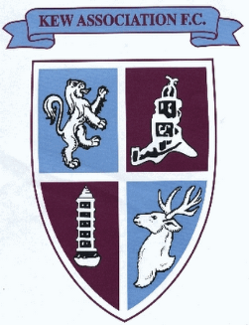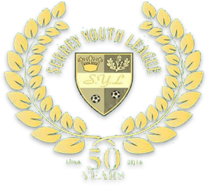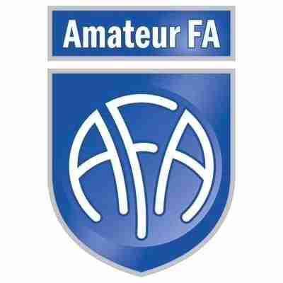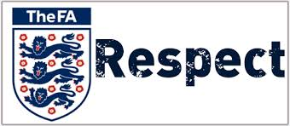

If you are looking at playing for a well organised and respected club then look no further as you have found the right club.
Kew AFC youth teams play in the Surrey Youth League which is considered one of the most well respected in the country.
Our age groups start from U7s to U18s with the majority of the age groups having at least two teams each.
Kew AFC are a Charter Standard Football Club, further details on what this means for your son or daughter can be found by copying and pasting into your browser http://www.thefa.com/get-involved/player/clubs-leagues/fa-charter-standard-programme/clubs . Our managers and coaches hold valid DBS checks in line with FA regulations and at least the minimum required Level 1 FA coaching course.
The Surrey Youth league play on Sundays and your son or daughter if selected will train weekly in preparation for their match on Sunday, training normally takes place on our fantastic 3Gs pitches or older teams might find themselves at an external local venue.
If you would like to play for us then please register your interest by copying and pasting this website into your browser http://kewafc.7dots.co.uk/ complete the form and submit.
Once received your details will be passed onto the relevant age group manager who will be in touch soon.
Trials are set for the 19th May 18/19 season and fixtures will commence in September 2018.
Please visit www.kewafc.co.uk for more information about the club.
We hope to hear from you soon!
Kew Association Football Club.
Kew and Ham Sports Facility, Ham Playing Fields, Ham, Richmond, Surrey, TW10 7RX.

